PERSONAL PROJECT TASKSHEET 2 PART 1
Task 1 Define a clear goal and global context for the project, based on personal  interests (Criterion Ai) | Based on personal interest, the student develops a clear goal that:  • justifies the goal as highly challenging  • meaningfully relates to a global context.
Task 2 Identify prior learning and subject-specific knowledge relevant to the project (Criterion Aii) | Analyses the relevance and contribution of prior learning to the project
Task 3 Demonstrate research skills (Criterion Aiii) | • An extensive range of sources and variety of source types have been researched.  • Sources are consistently and effectively evaluated for their reliability and relevance.  • The bibliography is appropriate, consistent and used with sophistication in the project.  • There is extensive evidence of a broad range of research skills.
NOTES FOR CRITERION A | Personal interest: Explaining the project’s value from a personal perspective by demonstrating intellectual curiosity; family connection; social, cultural or geographical relevance; individual passion—why this project makes sense for this student at this time.

Achievement level | Level descriptor
0 | The student does not reach a standard described by any of the descriptors below.
1–2 | The student is able to:  - state a goal and context for the project, based on personal interests, but this may be limited in depth or accessibility  - identify prior learning and subject-specific knowledge, but this may be limited in occurrence or relevance  - demonstrate limited research skills.
3–4 | The student is able to:  - outline a basic and appropriate goal and context for the project, based on personal interests  - identify basic prior learning and subject-specific knowledge relevant to some areas of the project  - demonstrate adequate research skills.
5–6 | The student is able to:  - define a clear and challenging goal and context for the project, based on personal interests  - identify prior learning and subject-specific knowledge generally relevant to the project  - demonstrate substantial research skills.
7–8 | The The student is able to:  - define a clear and highly challenging goal and context for the project, based on personal interests  - identify prior learning and subject-specific knowledge that is consistently highly relevant to the project  - demonstrate excellent research skills.

Criterion A
Achievement level:
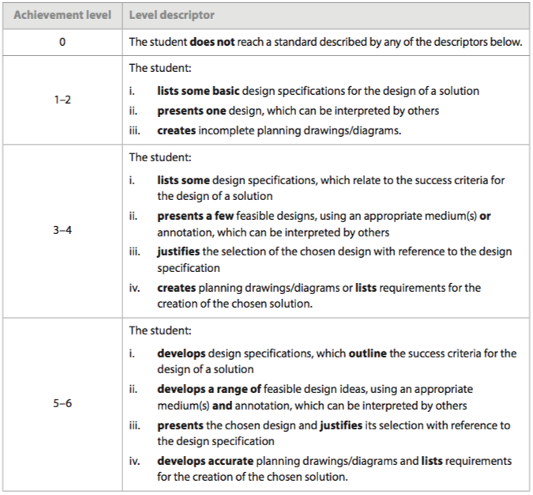
PERSONAL PROJECT TASKSHEET 2 PART 1
Task 1 Develop criteria for the product/outcome (Criterion Bi) | Criteria that:  - clearly define the specific characteristics of a high-quality product/outcome  - are explicitly informed by highly relevant research  - are justified, specific and multidimensional.
Task 2 Plan and record the development process of the project (Criterion Bii) | A plan that includes:  - short- and long-term planning broken down into detailed, logical steps  - a strong focus to the student’s project  - specific dates, deadlines and clear records of adjustment to the project’s timeline.  The record of the development process includes:  - a comprehensive account of the process from start to finish that corresponds closely to the plan  - changes that are clearly described and justified.
Task 3 Demonstrate self-management skills  (Criterion Biii) | A justification of:  • strengths and limitations for effective and independent time and task management  • affective skills practised through the project  • highly effective use of other self-management skills.
Task 4 Develop accurate and detailed planning drawings/diagrams and outline the requirements for the creation of the chosen solution (Criterion Biv) | You should develop accurate and detailed planning drawings/diagrams and outline requirements for the creation of the chosen solution.
NOTES FOR CRITERION B | Criteria: Standards of quality, developed by the student, which define the degree of excellence to which the product/outcome aspires; the terms under which the product/outcome can be judged to have been successful. Criteria should be personally challenging, specific, relevant, clearly-explained or exemplified, and observable or measurable. Criteria can have both qualitative and quantitative dimensions. These “indicators of success” may be explicitly stated in the report or included as an extract from the process journal referenced in the report.  Development: Changes or refinements in the student’s criteria made during the process of planning and taking action; students need to explain the nature and purpose of changes they make in the criteria they use to describe the project’s success.

Achievement level | Level descriptor
0 | The student does not reach a standard described by any of the descriptors below.
1–2 | The student is able to:  - develop limited criteria for the product/outcome  - present a limited or partial plan and record of the development process of the project  - demonstrate limited self-management skills.
3–4 | The student is able to:  - develop adequate criteria for the product/outcome  - present an adequate plan and record of the development process of the project  - demonstrate adequate self-management skills.
5–6 | The student is able to:  - develop substantial and appropriate criteria for the product/outcome  - present a substantial plan and record of the development process of the project  - demonstrate substantial self-management skills.
7–8 | The student is able to:  - develop rigorous criteria for the product/outcome  - present a detailed and accurate plan and record of the development process of the project  - demonstrate excellent self-management skills.

Criterion B
Achievement level:

